**Name: SHAMJAD MAZOOD NAZER**

**Roll No: 36**

**Batch: RMCA-B**

**Date: 23/05/2022**

**NETWORKING & SYSTEM ADMINISTRATION LAB**

**Experiment No.: 24**

**Aim**

Install Docker and run on Ubuntu

**Procedure**

1. Open the terminal on Ubuntu.

**Output Screenshot**



1. Remove any [Docker files](https://www.simplilearn.com/tutorials/docker-tutorial/what-is-dockerfile) that are running in the system, using the following command:

**$ sudo apt-get remove docker docker-engine docker.io**

**Output Screenshot**

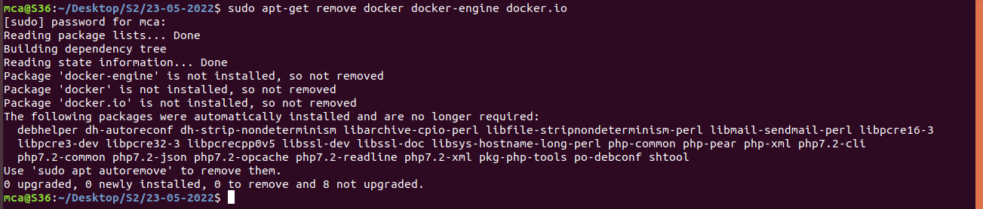

1. Check if the system is up-to-date using the following command:

**$ sudo apt-get update**

**Output Screenshot**

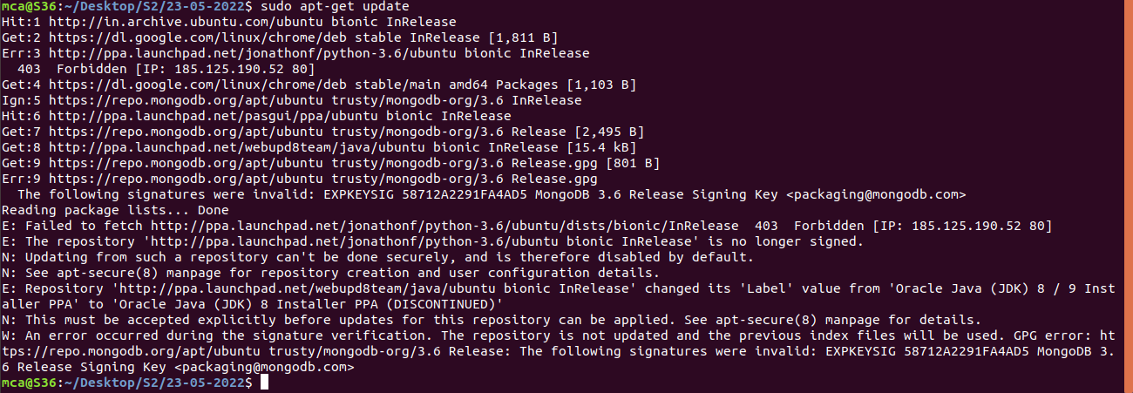

1. Install Docker using the following command:

**$ sudo apt install docker.io**

**Output Screenshot**

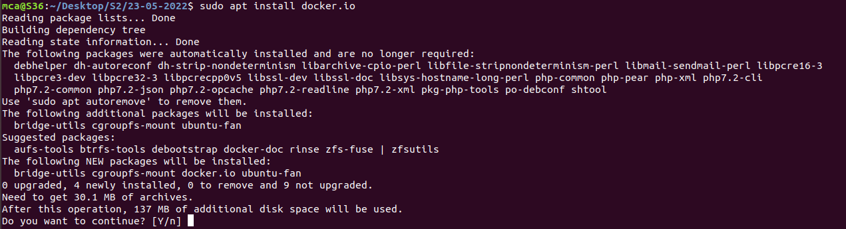

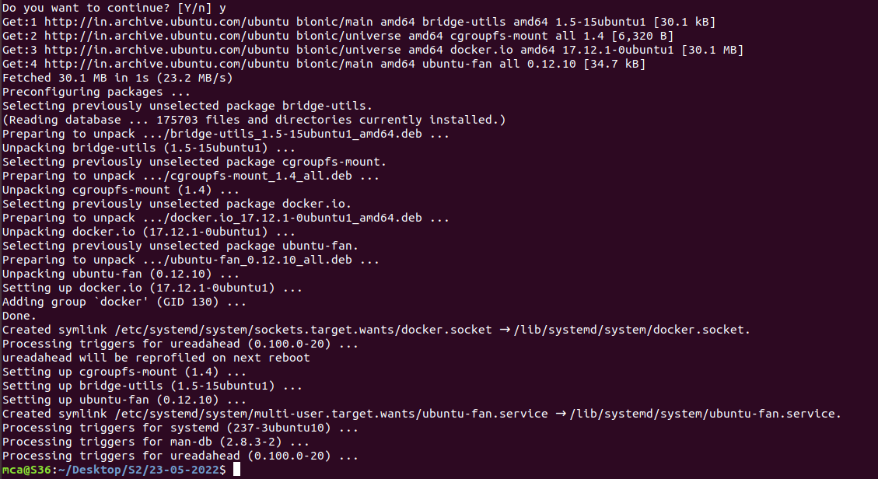

1. Install all the dependency packages using the following command:

**$ sudo snap install docker**

**Output Screenshot**



1. Before testing Docker, check the version installed using the following command:

**$ docker --version**

**Output Screenshot**



1. Pull an image from the Docker hub using the following command:

**$ sudo docker run hello-world**

**Output Screenshot**

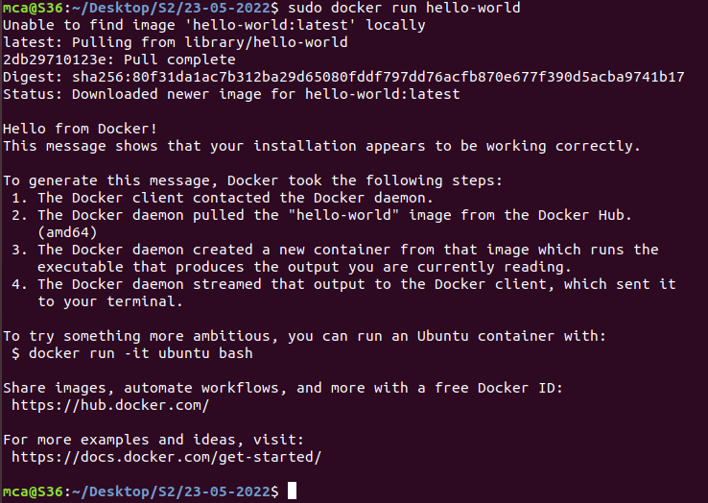

1. Check if the docker image has been pulled and is present in your system using the following command:

**$ sudo docker images**

**Output Screenshot**



1. To display all the containers pulled, use the following command:

**$ sudo docker ps -a**

**Output Screenshot**



1. To check for containers in a running state, use the following command:

**$ sudo docker ps**

**Output Screenshot**



You’ve just successfully installed Docker on Ubuntu!

**Name: SHAMJAD MAZOOD NAZER**

**Roll No: 36**

**Batch: RMCA-B**

**Date: 23/05/2022**

**NETWORKING & SYSTEM ADMINISTRATION LAB**

**Experiment No.: 25**

**Aim**

Install Docker and run on Ubuntu

**Procedure**